From:

A Practitioner's Guide To MMT, Part 1

by Tyler Durden
Wed, 04/24/2019 - 12:01
Authored by Kevin Muir via The Macro Tourist,
Lately there’s been a ton of talk about Modern Monetary Theory. Most of it critical. MMT seems to evoke a visceral gagging reflex from most finance-types, kind of like that feeling when your inappropriate uncle makes a lewd joke about your aunt.

However, I have been fascinated by the subject. And no one is more surprised by that fact than me. Although I am an economics major, if you would have suggested spending hours listening to a neo-classical economics professor drone on about the virtues of some DSGE model, I would have told you I would rather lick subway handrails. Yet over the past month I have spent tens of hours listening to a variety of MMT professors’ lectures.
The reason? MMT explains many of the current conundrums vexing traditional economic theory.
Now, now - before you click delete on the rest of my post, hear me out.
After thinking about the problems that the majority seem to have accepting MMT, I have concluded it best to divide MMT up into two components.
- One is the descriptive theory on how things are. This part deals with debt flows, banking reserves, etc… It describes the way a modern economy works.
- The next part is the prescriptive part of MMT. After understanding how an economy operates, many MMT advocates have policy recommendations. The important thing to understand about these choices is that they are political decisions based on economic theory. One might disagree with these courses of action, but it doesn’t change the first part - the descriptive part of MMT.

I am dividing my article into two posts. Today’s installment will focus on how to use MMT in today’s world. It will examine if the descriptive part can help us with trades in the current environment. Tomorrow’s post will delve into the ramifications for the markets if the prescriptive portion of MMT is adopted.
So let’s get on with it!

Using MMT in today’s market environment
I am often told “gee it’s great that you (kinda) understand MMT, so if it ever gets implemented, you will be way ahead of the curve.” I think that’s selling MMT short.
There are plenty of practical applications for MMT in today’s market environment.
Ever wonder why the three rounds of quantitative easing by the Federal Reserve didn’t cause the CPI increases the hyper-inflationists warned about? Or why Europe’s continued extreme monetary policy has failed to lift their economy? Or my favourite - why Japan’s debt-to-GDP ratio of 250% hasn’t caused an incendiary inflationary currency collapse?
Although neo-classical economists have been at a loss to forecast these economic realities, these perplexing outcomes are easily explained using MMT.
But before we examine the trading applications of MMT, let’s back up and think about the theory.

My MMT break through moment
During one of my early MMT-lecture marathons, Professor Stephanie Kelton explained that the government spent first and borrowed second. This didn’t seem correct and I couldn’t square it in my mind. Surely the government can’t spend without first borrowing. How do they spend money they don’t have? I thought this might be the beginnings of MMT-induced hallucinations, but I decided to press on.
Then Stephanie made it even more complicated by asserting the government need not borrow at all - the concept that they needed to issue bonds was a purely self imposed restraint.
At this point my mind was spinning. I grabbed hold of the bed frame hoping to slow down this terrible ride. It was like learning that WWE wrestling wasn’t real. It completely blew my mind and made me question all my assumptions about how an economy works.
After some time trying to process this new reality, I eventually figured out that this spending would be inflationary.
But that’s the whole point!

MMT’ers believe there is no financial constraint but only a real resource limit (subject to certain restrictions - only for sovereign countries who issue their own debt and don’t have a pegged currency, yada yada yada). In essence, inflation is the real limiting factor.
At this point you are probably saying that sounds a little like a ponzi scheme. How can a government spend without there being repercussions?
Well, no MMT practitioner would ever claim there are no consequences to government spending, it’s just that this spending is not limited by the ability of the government to borrow.
Still don’t believe me? Let’s think about war. Why is there always money for war?
Do you think that after the Japanese bombed Pearl Harbor the United States government went to the bond market to borrow money to build back their navy? And do you think that if the bond market had not provided those funds the United States government would have said, “sorry - we really want to enter the war, but we will have to wait until market conditions allow us to finance our deficit spending.”
Of course you don’t. The government spent first and did not worry about borrowing.
But wait, the history buffs will say, “there were war bonds, so MacroTourist - you are wrong”.
Well, let’s think about this bond issuance within the confines of MMT theory. The government did not issue war bonds to finance the spending, but to alter the private sector’s behaviour. Recall, the only constraint is in real terms. The government did not want individuals competing by buying goods that were needed in the war. So the government issued War Bonds to change their spending not to finance the war.
The important thing to realize is that
- governments always spend first and that
- bond issuance is simply a way of controlling inflation and altering private sector behaviour.
Ok great, maybe you buy that argument, but it still doesn’t help in trading today’s market.
Yet it does. In fact, it changes everything.

First trade - Japan
Let’s take the poster-child for today’s growth-starved world - Japan. They were the first major economy to engage in quantitative easing and the amount of debt they have racked up is mind-blowing.
Over the years (actually it’s been more than a decade now) there’s been all sorts of doomsday predictions from high-profile hedge fund managers about how it will all come tumbling down in a terrible inflationary collapse. And yeah, there is no denying, I fell for this storyline harder than for Halle Berry in a Bond movie.
But over the past few years there’s been a little part of me that wonders why all these dire predictions have failed to materialize. The skeptics will say the debt burden will eventually catch up with Japan and that you can’t borrow your way to prosperity. Yeah, yeah. I get it. I know all the arguments because I once made them myself.
However, the first seeds of doubt about this theory were sown well before I had ever heard of MMT.
Back in 2017, there were two terrific interviews on Real Vision with Bill Fleckenstein and David Zervos. Fleck’s piece was titled, “Japanese Debt Wipeout can they get away with it?” (subscription required). It was transforming as it made me question everything I thought I understood about the Japanese endgame. And then David Zervos followed it up with “Deregulation & Debt Jubilees” (again subscription required).
Although there were subtle differences in their opinions, both Bill and David introduced the concept that maybe the Bank of Japan would simply tear up all the JGBs it owned and start over.
I can hear the groans again. You can’t just tear up debt. It doesn’t work that way!
Really?
The BoJ owns approximately 43% of the outstanding Japanese government debt.
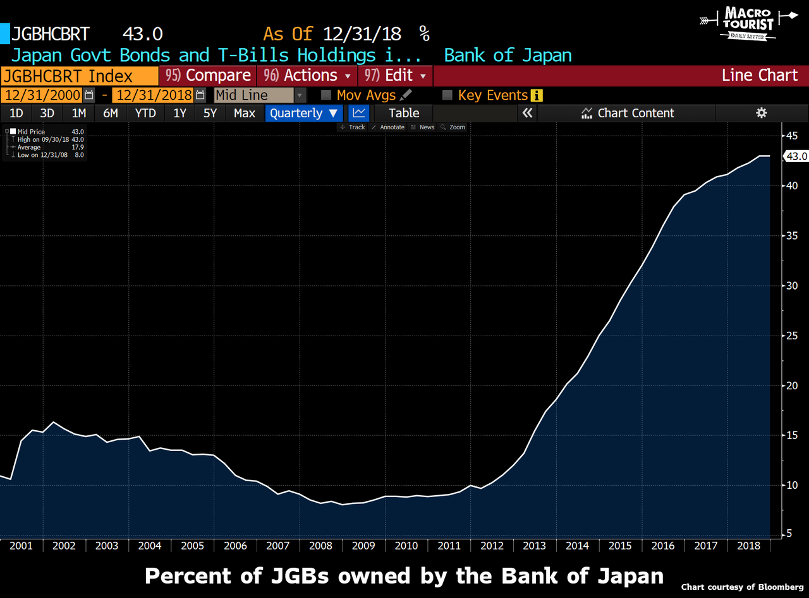
That debt is sitting on their balance sheet and since interest rates are basically zero, it’s not doing much. The Japanese government issued that debt and then the Bank of Japan bought it back. It nets out to a zero between the two entities. We could have avoided the Japanese broker middlemen if the government had just spent the money and never bothered with the steps in between.
Wait, wait, wait…
Remember back to Stephanie’s comment that the government could spend money it doesn’t have and it didn’t even need to issue bonds? Well, in essence this is what the Japanese government is doing. Why bother issuing debt to only have the BoJ buy it back? Why not just spend the money and avoid the hocus-pocus in the middle?
Think back to the pushback you had about the government spending money directly. You probably thought it would cause hyper-inflation. [Yeah, I did. –FNC]
Yet where is the hyper-inflation in Japan?
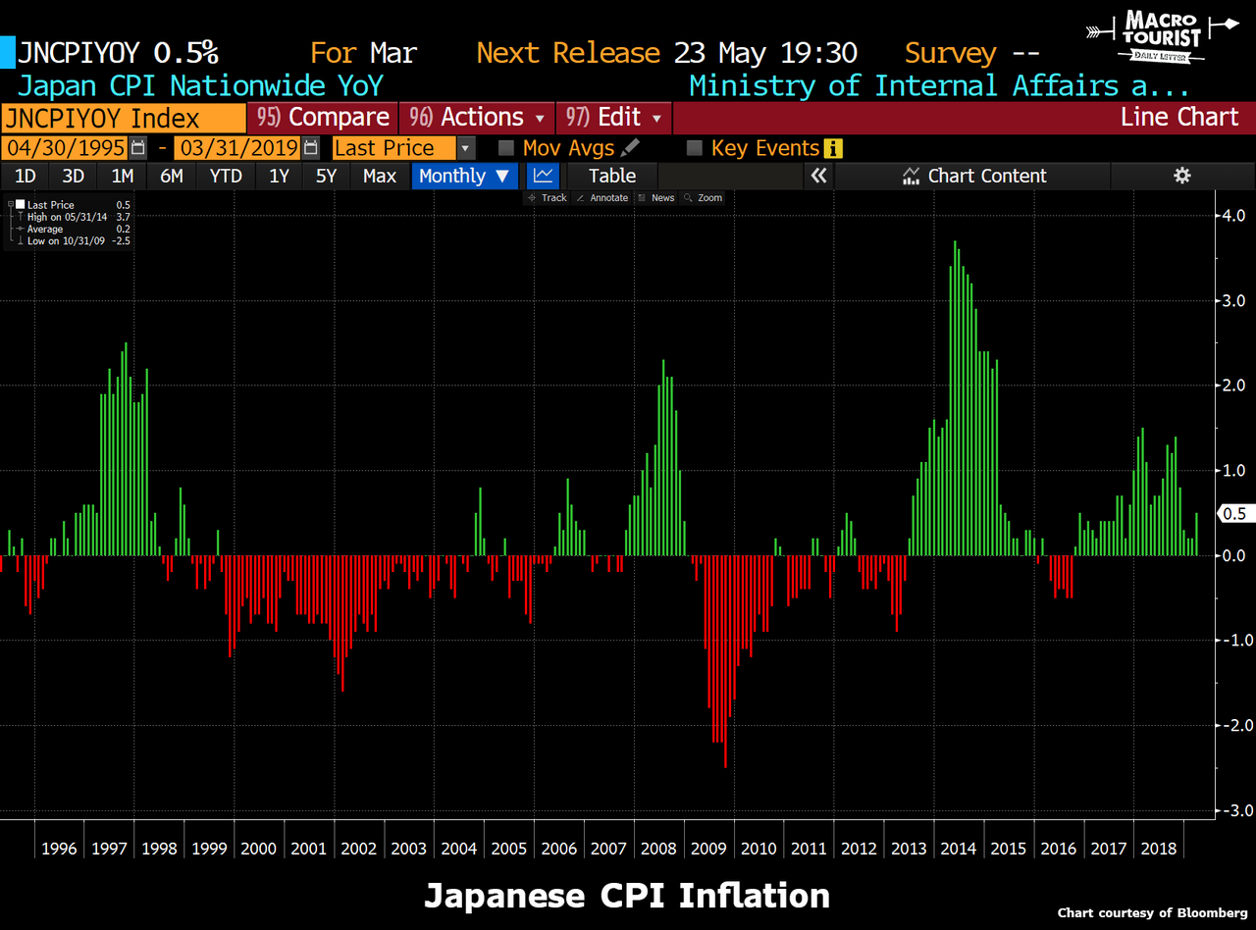
Apart from a spike when the government raised the value-added tax rate, inflation has struggled in Japan. In fact, they have had more of a problem with deflation than inflation.
So even though the Japanese are running a deficit of between 3% and 4% of GDP with a debt-to-GDP of 250%, and then basically monetizing approximately half of that spending through quantitative easing, they still can’t hit their inflation target.
Which brings me to a comment made by Bill Mitchell - one of the core members in the group of founding MMT professors - and I am paraphrasing here, but he said something to the effect that there are different levels of deficits required for different economies. So whereas in Japan they might need a deficit of 10% of GDP to take up the resource slack, in another country, 1% surplus might be inflationary. It all depends on the external account and other macroeconomic factors.
But let’s go back to how this helps in our trading in today’s market. Bill Fleckenstein and David Zervos argued that a debt jubilee in Japan might not be as catastrophic as many predict. Their argument basically boils down to “the BoJ already owns the debt anyway, so it’s really just an accounting entry - from the BoJ to the Japanese government. Ripping up the bonds held on the BoJ balance sheet would have no real change to the economic situation. The currency would probably fall, but then foreigners might look at the circumstances and decide that with the Yen at 150 or 180 or 200, Japan is on sale. The real productive assets of Japan would have not changed, so they would buy Japan. Also, the new lower currency would be a boon for exports and the Japanese economy might take off.”
This was ground breaking to me. It showed originality in their thinking. And I suggest you watch both interviews in their entirety - I believe them to be that important.
However, after spending the last couple of months immersing myself in MMT theory, I have come to the conclusion that maybe even Bill and David are overestimating the effects of a Japanese debt jubilee. Let’s imagine for a second that the BoJ has already ripped up the JGBs it holds in secret behind closed doors. Would anything have changed in the real economy? I contend that no, nothing would have changed in the slightest. Therefore in my mind, whether they rip them up or not doesn’t matter.
The only real change would be that suddenly the Japanese government would have a lot more “perceived” room to spend. This ability to spend would be construed as inflationary by the market and therefore asset prices might change in anticipation of future policy changes.
I am not denying that markets would be confused by a Bank of Japan debt jubilee. Don’t forget all the hyperbolic warnings in the advent of the first US quantitative easing program, and then the continued end-of-the-world predictions in the second and third QE programs. The markets took quite a while to sort out the true ramifications of these policies. If Japan went down their debt jubilee road, there would be even more dire warnings emanating from the neo-classical and Austrian economic community.
But remember - the only thing that is actually inflationary is government policy changes going forward. Otherwise, the inflation has already been felt when the deficit was created.
Now what does this mean for trades today? Well, if you have been betting on Japan collapsing because of its high debt-to-GDP ratio, I humbly suggest you are looking at the wrong metric.
The only reason the current high debt-to-GDP ratio hampers the economy is because it influences government policy. If the Fleck/Zervos debt jubilee comes closer to reality, I would view any sell off in the Yen as a chance to buy Japan on sale.
But more importantly, maybe the high debt ratios are suppressing global equity managers allocation to Japan. Maybe they have been reluctant to invest in Japan in fear of a Japanese collapse. And yet, maybe it’s not coming and all their fear does is provide a great long term entry into Japanese equities by keeping them underpriced versus the rest of the world.

Next trade - Europe
Now that we understand the basics of MMT theory, let’s apply them to Europe. Remember that different economies require different levels of fiscal deficits. It’s not that MMT theory advocates that governments should always spend, but it does conclude it is foolish to administer increasing amounts of monetary stimulus in an attempt to kickstart an economy.
MMT’ers argue that the policy prescription of extremely accommodative monetary policy while insisting on fiscal austerity is a recipe for a moribund economy. Yet this is exactly what Europe is insisting to be the solution to their problem.
Before understanding the way a modern economy works, I was in the Bill Gross camp that the easy money in Europe would eventually cause the German bund to be the short of a lifetime. Now I have a little better idea about the timing of that trade.
I no longer believe there is any sense in being positioned for a secular short in bunds until we see Germany change their allowance for Europe to run government deficits. Italy is being chastised for trying to run a deficit of 2.5% of GDP, yet the United States is running more than 4%.
You might argue that Italy and the United States are completely different and that Germany is correct to insist on fiscal austerity throughout Europe. That’s a political decision with economic implications.
Regardless of whether I believe this policy prescription to be right or wrong, I am firmly convinced it will mean chronic poor economic performance in Europe. Therefore, avoid European equities and don’t short bunds until this changes.
Will there be tradeable rallies in European equities? For sure. But don’t get too bullish until European officials change their tune.

Final trade - United States
I wrote a piece titled “Trump: The first MMT President” where I outlined all the reasons the President’s policies were much more MMT-like than any on the right would care to admit.
I even saw a Vice-President Pence interview the other day where they asked him why the administration was pushing for lower rates if the economy was as strong as they bragged. His reply was quintessential MMT. Pence said, “because there is no inflation.”
As long as President Trump’s administration continues with their policies, then I suspect the United States economy will continue to outperform.
Now there are always many moving parts, but the United States’ economic policies are the best example of MMT at work. You might not like them. You might think tax cuts are not the best use of fiscal stimulus. Again, those are political considerations.
Knowing how modern economies work explains why America has outperformed Europe since the Great Financial Crisis, and although there are other secular influences also at work, don’t assume this trend will change until you see a shift in attitudes in either country regarding deficits and spending.

Summing it up
The majority of you will most likely still not be MMT converts. I get it. It’s difficult to accept the move from neo-classical or Austrian economics.

I would like to reaffirm one point. There are two parts to MMT; how the modern fiat-based economy works and then the policies that are advocated to maximize output under these conditions.
You might not like the political parts of MMT. I am not trying to convert anyone. Nothing is more annoying than when your best friend discovers some keto-diet and spends all day extolling its benefits.
But I will let you in on a little secret. When I wrote my original MMT piece - “Everything you wanted to know about MMT (but were afraid to ask)”, I was shocked by the individuals who reached out to me. Really impressive people who had spent time examining MMT and concluded that it was extremely useful in their analytical thinking. They sent me papers they had written, notes they had taken from their meetings with these MMT professors and analysis they had created in their attempt to better understand the modern economy and markets. The quality of these people and their thinking astounded me.
It’s easy to dismiss MMT as the ravings of the far-left, but if you do so, you are mixing economics with politics. MMT theory is extremely useful in understanding how the economy actually works. You might not like it. You might wish it were different. But I think the hallmark of a great trader/investor is to stay open-minded. In that vein, I think the MMT framework is a most useful tool for macro trading.
When Nixon went off the gold standard, economics changed. Yet all the textbooks are still based on this neo-classical economic thinking. Understanding that the old economic concepts no longer work and the current situation is much different, helps in accepting that MMT does a much better job at explaining today’s realities than any other framework.
So yeah, I guess I am proud to say that I think MMT is an extremely valuable tool. You might scoff at that idea. You might write me off as some wingnut. But just remember, I still like the Indy 500.

